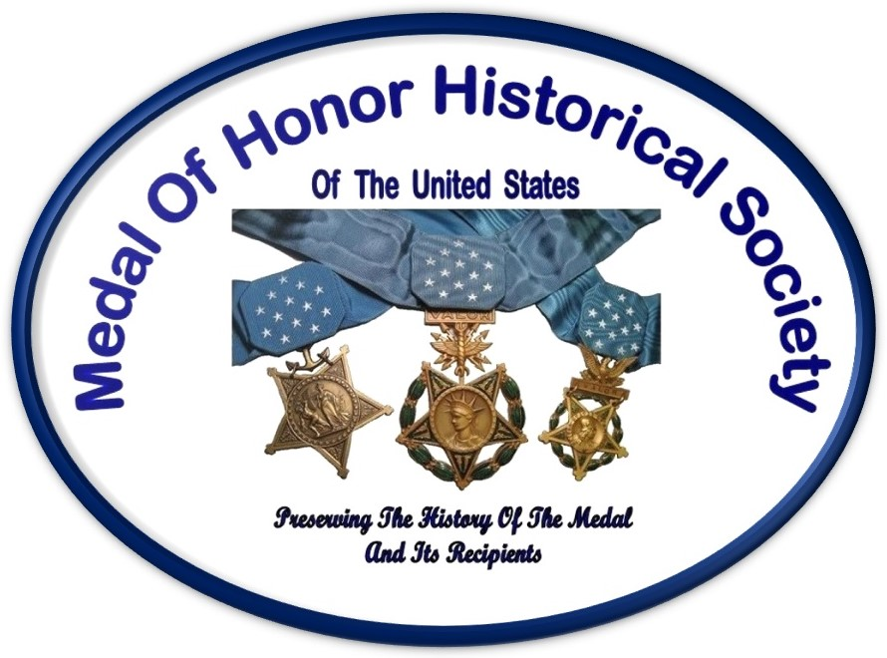 | MEDAL OF HONOR HISTORICAL SOCIETY OF THE UNITED STATES  Donation/Membership Application/Renewal Form
YES! I support the Medal of Honor Historical Society of the United States and would like to receive Above and Beyond, its quarterly newsletter. Please enter my membership application in the category checked below. I have enclosed a check or money order in the amount indicated and I am pleased to accept my canceled check as my receipt. (The MoHHSUS is a 501(c)(3) organization.)

$20 [ ] General $50 [ ] Organizational

[ ] Medal of Honor Recipient - Honorary member
exempt from dues with the same rights
as that of a General member.

Donation: $ For: ______________________________________________________________

If making a donation in memory of an individual, please give us their name and family's address so we can inform the family of your gift.  If you wish your gift to remain anonymous, please check here [ ] | I wish to make a donation in memory of:  (Name of Individual & address of family)  ________________________________  ________________________________  ________________________________

Total Amount Enclosed: $____________________________________

Name: ______________________________________________ Phone: ________________________

Address: _________________________________________________________________________________
(City, State, Zip)

E-Mail: ___________________________________________________________________________________
(The majority of our communications to include sending of our electronic newsletter will be via e-mail. We do not make membership information, addresses or e-mail addresses available to other organizations.)

Have you researched or written a paper or book on a specific person, battle or war? Please tell us about it.

__________________________________________________________________________________________
(This is not mandatory, it just lets us know your area of expertise in case we receive an inquiry related to your line of research that you may be able to assist with.)
Please make checks payable to Medal of Honor Historical Society of the United States (MOHHSUS) and mail check and form to: Medal of Honor Historical Society of the United States, P.O. Box 1345
Meridian, ID 83680

